**Module 10 – Single Page Application framework – React**

**11.ReactJS-HOL**

**React Events**

React handles events using a synthetic event system (like onClick, onChange) which wraps around native events for better performance and cross-browser compatibility.

**Event Handlers**

Event handlers are functions triggered in response to user actions like clicking a button or submitting a form.

**Synthetic Event**

React’s synthetic events wrap native browser events, making them consistent across browsers.

**React Event Naming Convention**

React uses **camelCase** for event names (e.g., onClick, onChange) instead of lowercase like in HTML (onclick, onchange).

**Structure:**

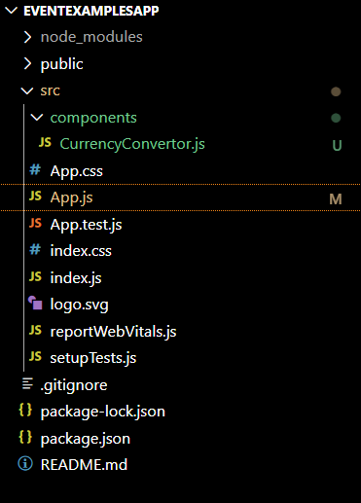

**CurrencyConvertor.js:**

import React, { Component } from 'react';

class CurrencyConvertor extends Component {

  constructor(props) {

    super(props);

    this.state = {

      amount: '',

      currency: 'Euro'

    };

  }

  handleAmountChange = (e) => {

    this.setState({ amount: e.target.value });

  };

  handleCurrencyChange = (e) => {

    this.setState({ currency: e.target.value });

  };

  handleSubmit = (e) => {

    e.preventDefault();

    const { amount, currency } = this.state;

    let result;

    if (currency === "Euro") {

      result = amount * 80; // Example conversion: 1 Euro = ₹80

    } else {

      result = amount / 80; // Reverse if needed

    }

    alert(`Converting to ${currency} Amount is ${result}`);

  };

  render() {

    return (

      <div>

        <h2 style={{ color: 'green', fontFamily: 'Arial Black' }}>Currency Convertor!!!</h2>

        <form onSubmit={this.handleSubmit}>

          <label>

            Amount:

            <input

              type="number"

              value={this.state.amount}

              onChange={this.handleAmountChange}

              style={{ marginLeft: '10px' }}

              required

            />

          </label>

          <br /><br />

          <label>

            Currency:

            <select

              value={this.state.currency}

              onChange={this.handleCurrencyChange}

              style={{ marginLeft: '10px' }}

            >

              <option value="Euro">Euro</option>

              <option value="INR">INR</option>

            </select>

          </label>

          <br /><br />

          <button type="submit">Submit</button>

        </form>

      </div>

    );

  }

}

export default CurrencyConvertor;

**App.js:**

import React, { Component } from 'react';

import CurrencyConvertor from './components/CurrencyConvertor';

class App extends Component {

  constructor(props) {

    super(props);

    this.state = {

      count: 1

    };

  }

  increment = () => {

    this.setState({ count: this.state.count + 1 });

    this.sayHello();

  };

  decrement = () => {

    this.setState({ count: this.state.count - 1 });

  };

  sayHello = () => {

    console.log("Hello! This is a static message.");

  };

  sayWelcome = (msg) => {

    alert(msg);

  };

  handleClick = (e) => {

    alert("I was clicked");

  };

  render() {

    return (

      <div style={{ padding: '30px' }}>

        <div>

          <p>{this.state.count}</p>

          <button onClick={this.increment}>Increment</button><br /><br />

          <button onClick={this.decrement}>Decrement</button><br /><br />

          <button onClick={() => this.sayWelcome("Say welcome")}>Say welcome</button><br /><br />

          <button onClick={this.handleClick}>Click on me</button>

        </div>

        <br /><br />

        <CurrencyConvertor />

      </div>

    );

  }

}

export default App;

**Output:**

